Predicting Movie Revenue Using Regression Models
Aarjab Marick 715
2026-05-03
Table of Contents
1. Data Loading and Merging 2
2. JSON Parsing and Feature Extraction 2
3. Data Cleaning 4
4. Exploratory Data Analysis 5
5. Feature Engineering 13
6. Train/Test Split 14
7. OLS Regression 14
8. Variable Selection 18
8a. Forward Stepwise Selection 18
8b. Backward Stepwise Selection 19
8c. Best Subset Selection 21
9. Ridge Regression 22
10. Lasso Regression 24
11. Elastic Net Regression 26
12. KNN Regression 27
13. Logistic Regression (Hit or Flop?) 29
14. Model Comparison 30
15. Conclusion 31

# Core libraries used throughout the project
library(tidyverse)
library(jsonlite)
library(knitr)
library(ggplot2)
library(caret)
library(glmnet)
library(leaps)
library(MASS)
library(corrplot)

1. Data Loading and Merging
The TMDB 5000 dataset comes in two CSV files: one with movie-level metadata and one with cast/crew information. Each file has roughly 4,800 rows. We load both files and merge them on the movie ID key (id in the movies file, movie_id in the credits file). After merging, we drop the duplicate title column from the credits side so the final frame has one row per movie.
movies <- read.csv("tmdb_5000_movies.csv", stringsAsFactors = FALSE)
credits <- read.csv("tmdb_5000_credits.csv", stringsAsFactors = FALSE)
# Merge on id == movie_id
df <- merge(movies, credits, by.x = "id", by.y = "movie_id")
# Drop the duplicated title column (title.y) and rename title.x back to title
df$title <- df$title.x
df$title.x <- NULL
df$title.y <- NULL
cat("Dimensions after merge:", dim(df), "\n")
## Dimensions after merge: 4803 22
kable(head(df[, c("id", "title", "budget", "revenue", "runtime")], 5),
caption = "First five rows of the merged dataset")
First five rows of the merged dataset
id | title | budget | revenue | runtime
5 | Four Rooms | 4.0e+06 | 4300000 | 98
11 | Star Wars | 1.1e+07 | 775398007 | 121
12 | Finding Nemo | 9.4e+07 | 940335536 | 100
13 | Forrest Gump | 5.5e+07 | 677945399 | 142
14 | American Beauty | 1.5e+07 | 356296601 | 122

2. JSON Parsing and Feature Extraction
Several columns in the dataset are stored as JSON strings rather than ordinary text. For example, genres is a list of {id, name} objects and crew is a list of crew members each with a job field. We use jsonlite::fromJSON() row by row to pull out the fields we care about. Empty arrays and parse failures are handled by returning NA (or 0 for counts), which keeps the pipeline from crashing on malformed entries.
# Helper: get the first genre name from the genres JSON
get_first_genre <- function(json_str) {
if (is.na(json_str) || json_str == "" || json_str == "[]") return(NA)
parsed <- tryCatch(fromJSON(json_str), error = function(e) NULL)
if (is.null(parsed) || length(parsed) == 0) return(NA)
if (!"name" %in% names(parsed)) return(NA)
parsed$name[1]
}
# Helper: get the first director from the crew JSON
get_director <- function(json_str) {
if (is.na(json_str) || json_str == "" || json_str == "[]") return(NA)
parsed <- tryCatch(fromJSON(json_str), error = function(e) NULL)
if (is.null(parsed) || length(parsed) == 0) return(NA)
if (!"job" %in% names(parsed)) return(NA)
dirs <- parsed$name[parsed$job == "Director"]
if (length(dirs) == 0) return(NA)
dirs[1]
}
# Helper: count the number of cast members
get_cast_size <- function(json_str) {
if (is.na(json_str) || json_str == "" || json_str == "[]") return(0)
parsed <- tryCatch(fromJSON(json_str), error = function(e) NULL)
if (is.null(parsed) || length(parsed) == 0) return(0)
nrow(parsed)
}
# Helper: count the number of production companies
get_num_companies <- function(json_str) {
if (is.na(json_str) || json_str == "" || json_str == "[]") return(0)
parsed <- tryCatch(fromJSON(json_str), error = function(e) NULL)
if (is.null(parsed) || length(parsed) == 0) return(0)
nrow(parsed)
}
The helpers above are now applied to each relevant column. Because sapply walks down the column one row at a time, this can be slow on big data, but for ~4,800 movies it finishes in a few seconds. The new columns are added back to the main data frame.
df$primary_genre <- sapply(df$genres, get_first_genre)
df$director <- sapply(df$crew, get_director)
df$cast_size <- sapply(df$cast, get_cast_size)
df$num_companies <- sapply(df$production_companies, get_num_companies)
# Quick sanity check of the new columns
kable(head(df[, c("title", "primary_genre", "director", "cast_size", "num_companies")], 6),
caption = "Extracted features from JSON columns")
Extracted features from JSON columns
title | primary_genre | director | cast_size | num_companies
Four Rooms | Crime | Allison Anders | 24 | 2
Star Wars | Adventure | George Lucas | 106 | 2
Finding Nemo | Animation | Andrew Stanton | 24 | 1
Forrest Gump | Comedy | Robert Zemeckis | 66 | 1
American Beauty | Drama | Sam Mendes | 40 | 2
Dancer in the Dark | Drama | Lars von Trier | 29 | 26

3. Data Cleaning
A large fraction of TMDB rows have budget == 0 or revenue == 0, which almost always means the field was not reported rather than the movie literally making no money. We drop these. We also extract the release year as a numeric variable, drop free-text and identifier columns we will not use as predictors, and impute remaining numeric NAs with the column median.
# Drop rows with missing or zero budget/revenue
df_clean <- df %>%
filter(!is.na(revenue), !is.na(budget),
revenue > 0, budget > 0)
# Extract release year
df_clean$release_year <- as.numeric(format(as.Date(df_clean$release_date), "%Y"))
# Drop columns we will not use as predictors
drop_cols <- c("homepage", "overview", "tagline", "original_title",
"keywords", "genres", "production_companies", "production_countries",
"spoken_languages", "status", "cast", "crew", "release_date",
"id", "title", "director")
df_clean <- df_clean[, !(names(df_clean) %in% drop_cols)]
# Impute remaining numeric NAs with median (mainly runtime)
num_cols <- sapply(df_clean, is.numeric)
for (col in names(df_clean)[num_cols]) {
if (any(is.na(df_clean[[col]]))) {
df_clean[[col]][is.na(df_clean[[col]])] <-
median(df_clean[[col]], na.rm = TRUE)
}
}
# Drop any rows still missing primary_genre or release_year
df_clean <- df_clean %>%
filter(!is.na(primary_genre), !is.na(release_year))
cat("Dimensions after cleaning:", dim(df_clean), "\n")
## Dimensions after cleaning: 3228 11
kable(summary(df_clean[, c("budget", "revenue", "popularity",
"runtime", "vote_average", "vote_count")]),
caption = "Summary of key numeric variables after cleaning")
Summary of key numeric variables after cleaning
 | budget | revenue | popularity | runtime | vote_average | vote_count
 | Min. : 1 | Min. :5.000e+00 | Min. : 0.01998 | Min. : 41.0 | Min. :0.00 | Min. : 0.0
 | 1st Qu.: 10500000 | 1st Qu.:1.700e+07 | 1st Qu.: 10.46821 | 1st Qu.: 96.0 | 1st Qu.:5.80 | 1st Qu.: 178.0
 | Median : 25000000 | Median :5.519e+07 | Median : 20.41296 | Median :107.0 | Median :6.30 | Median : 471.0
 | Mean : 40666420 | Mean :1.213e+08 | Mean : 29.04267 | Mean :110.7 | Mean :6.31 | Mean : 977.6
 | 3rd Qu.: 55000000 | 3rd Qu.:1.463e+08 | 3rd Qu.: 37.34075 | 3rd Qu.:121.0 | 3rd Qu.:6.90 | 3rd Qu.: 1148.0
 | Max. :380000000 | Max. :2.788e+09 | Max. :875.58130 | Max. :338.0 | Max. :8.50 | Max. :13752.0

4. Exploratory Data Analysis
Before modelling we look at the data visually to understand its scale and shape. The summary table below reports the mean, median, standard deviation, minimum and maximum for every numeric variable. This is the kind of overview that often reveals heavy skew or outliers right away.
numeric_df <- df_clean[, sapply(df_clean, is.numeric)]
summary_tbl <- data.frame(
Mean = sapply(numeric_df, mean, na.rm = TRUE),
Median = sapply(numeric_df, median, na.rm = TRUE),
SD = sapply(numeric_df, sd, na.rm = TRUE),
Min = sapply(numeric_df, min, na.rm = TRUE),
Max = sapply(numeric_df, max, na.rm = TRUE)
)
kable(round(summary_tbl, 2), caption = "Summary statistics for numeric variables")
Summary statistics for numeric variables
 | Mean | Median | SD | Min | Max
budget | 40666419.51 | 25000000.00 | 44398404.53 | 1.00 | 3.800000e+08
popularity | 29.04 | 20.41 | 36.17 | 0.02 | 8.755800e+02
revenue | 121279998.84 | 55191503.00 | 186319835.39 | 5.00 | 2.787965e+09
runtime | 110.72 | 107.00 | 20.97 | 41.00 | 3.380000e+02
vote_average | 6.31 | 6.30 | 0.87 | 0.00 | 8.500000e+00
vote_count | 977.59 | 471.00 | 1414.42 | 0.00 | 1.375200e+04
cast_size | 26.04 | 19.00 | 21.48 | 0.00 | 2.240000e+02
num_companies | 3.20 | 3.00 | 2.17 | 0.00 | 2.600000e+01
release_year | 2001.68 | 2005.00 | 13.28 | 1916.00 | 2.016000e+03
The histogram of raw revenue is heavily right-skewed: a handful of blockbusters dwarf the bulk of the distribution. This violates the normality and constant-variance assumptions of linear regression and motivates a log transform. After taking $log(\text{revenue})$, the distribution becomes much closer to bell-shaped, which is a better target for OLS and friends.
ggplot(df_clean, aes(x = revenue)) +
geom_histogram(bins = 50, fill = "steelblue", colour = "white") +
scale_x_continuous(labels = scales::comma) +
labs(title = "Distribution of revenue (raw)",
x = "Revenue (USD)", y = "Count") +
theme_minimal()
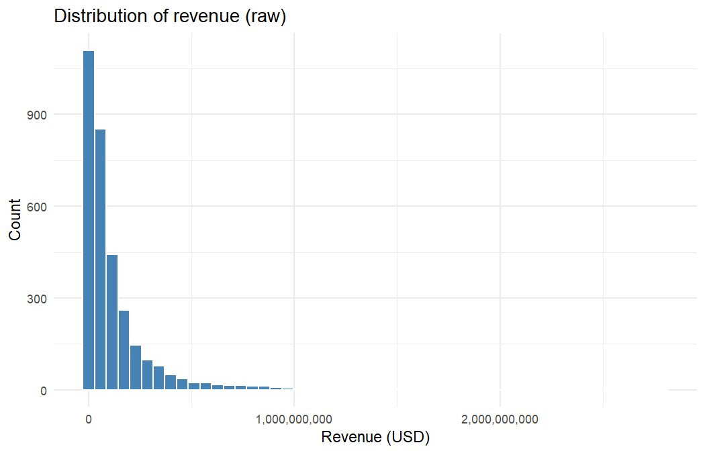
ggplot(df_clean, aes(x = log(revenue))) +
geom_histogram(bins = 50, fill = "darkorange", colour = "white") +
labs(title = "Distribution of log(revenue)",
x = "log(Revenue)", y = "Count") +
theme_minimal()
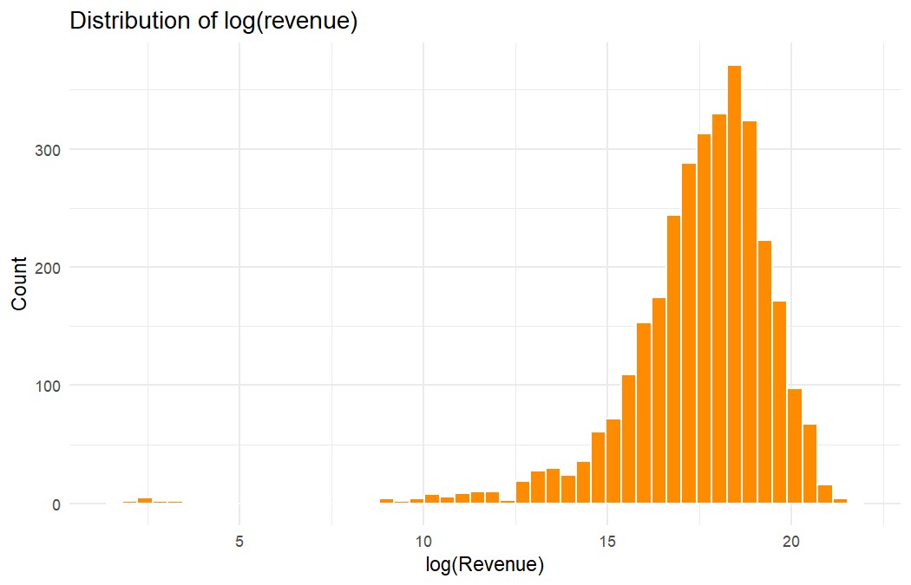
The same skew shows up in budget, popularity and vote_count — all of them are heavy tailed. runtime and vote_average are roughly bell-shaped already. The four panels below give a quick visual sense of each predictor.
par(mfrow = c(2, 2))
hist(df_clean$budget, main = "Budget", xlab = "Budget", col = "lightblue")
hist(df_clean$popularity, main = "Popularity", xlab = "Popularity", col = "lightgreen")
hist(df_clean$runtime, main = "Runtime", xlab = "Runtime (min)", col = "lightpink")
hist(df_clean$vote_average, main = "Vote Average", xlab = "Vote Average", col = "lightyellow")
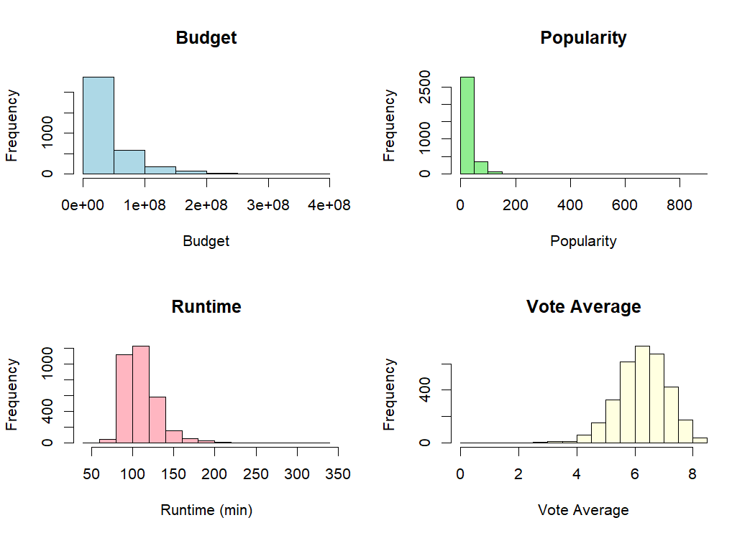
par(mfrow = c(1, 1))
The scatter plot below confirms the strong, roughly linear relationship between log-budget and log-revenue. Movies that spend more tend to earn more, which is the single most important pattern in this dataset.
ggplot(df_clean, aes(x = log(budget), y = log(revenue))) +
geom_point(alpha = 0.4, colour = "steelblue") +
geom_smooth(method = "lm", colour = "red", se = FALSE) +
labs(title = "log(Revenue) vs log(Budget)",
x = "log(Budget)", y = "log(Revenue)") +
theme_minimal()
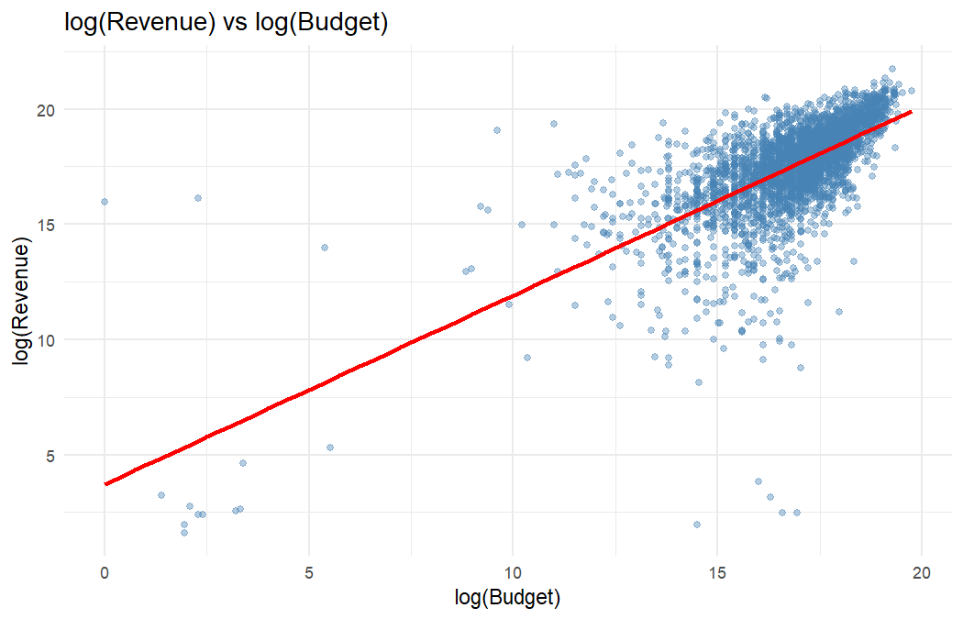
Genres differ a fair bit in their revenue distributions. Animated and adventure films skew higher; documentaries and dramas sit lower. We restrict the boxplot to the eight most common genres so the comparison is meaningful.
top_genres <- names(sort(table(df_clean$primary_genre), decreasing = TRUE))[1:8]
df_top <- df_clean %>% filter(primary_genre %in% top_genres)
ggplot(df_top, aes(x = reorder(primary_genre, log(revenue), FUN = median),
y = log(revenue))) +
geom_boxplot(fill = "lightblue") +
coord_flip() +
labs(title = "log(Revenue) by primary genre (top 8)",
x = "Genre", y = "log(Revenue)") +
theme_minimal()
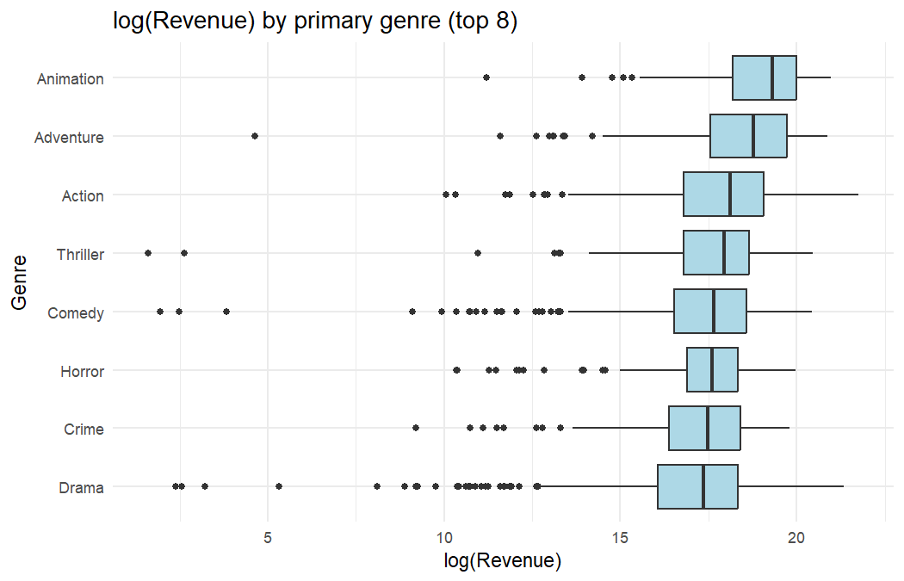
Most movies in the dataset are in English, but it is still useful to look at average revenue across the most common languages. English films average notably higher revenues than the others, which partly reflects distribution reach rather than quality.
top_langs <- names(sort(table(df_clean$original_language), decreasing = TRUE))[1:8]
lang_df <- df_clean %>%
filter(original_language %in% top_langs) %>%
group_by(original_language) %>%
summarise(avg_revenue = mean(revenue))
ggplot(lang_df, aes(x = reorder(original_language, avg_revenue),
y = avg_revenue)) +
geom_col(fill = "tomato") +
coord_flip() +
scale_y_continuous(labels = scales::comma) +
labs(title = "Average revenue by original language (top 8)",
x = "Language", y = "Average Revenue (USD)") +
theme_minimal()
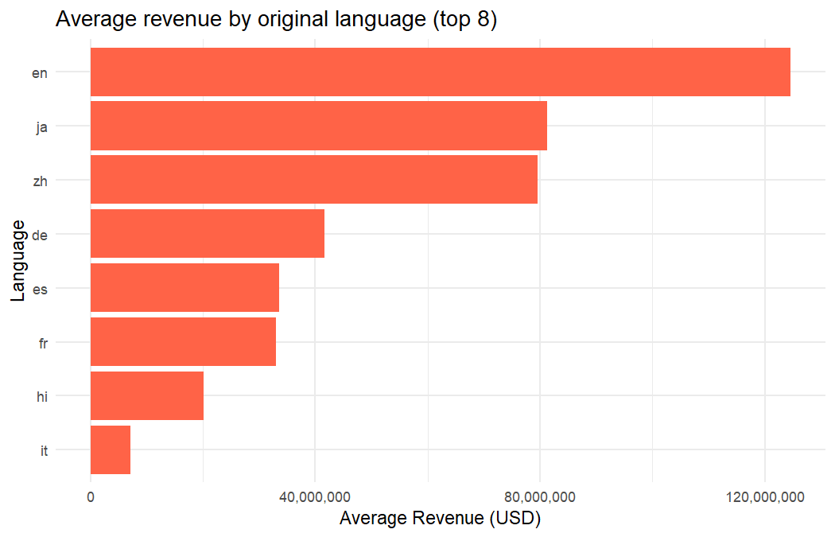
Average revenue has trended upward over time, especially after the late 1990s. Some of this is real growth and some is inflation plus better global distribution. We will keep release_year as a numeric predictor.
year_df <- df_clean %>%
group_by(release_year) %>%
summarise(avg_revenue = mean(revenue), n = n()) %>%
filter(n >= 5)
ggplot(year_df, aes(x = release_year, y = avg_revenue)) +
geom_point(colour = "steelblue") +
geom_smooth(se = FALSE, colour = "red") +
scale_y_continuous(labels = scales::comma) +
labs(title = "Average revenue by release year",
x = "Release Year", y = "Average Revenue (USD)") +
theme_minimal()
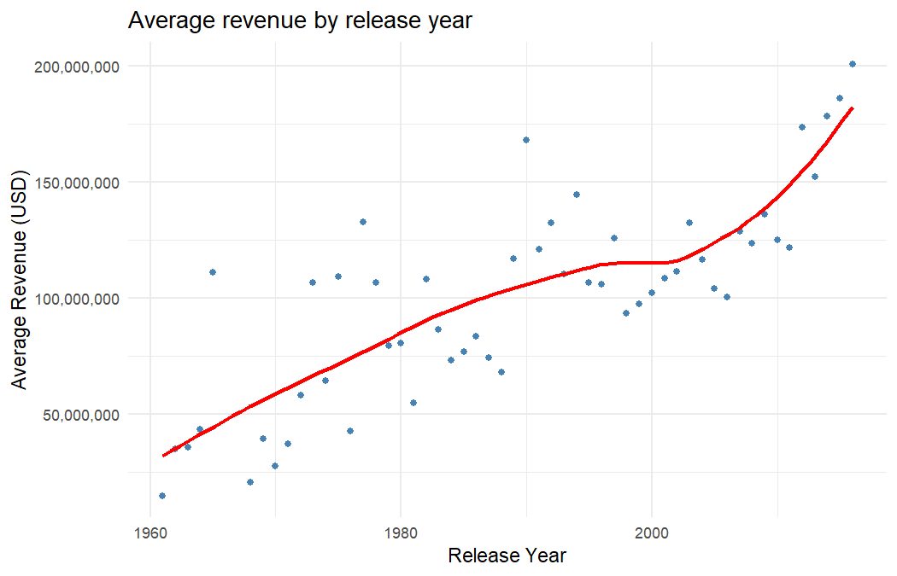
The correlation heatmap below shows that budget, vote_count and popularity are the variables most strongly correlated with revenue. vote_count and popularity are also moderately correlated with each other, which is a small multicollinearity concern that ridge and lasso can help with later.
corr_mat <- cor(numeric_df, use = "complete.obs")
corrplot(corr_mat, method = "color", type = "upper",
tl.col = "black", tl.cex = 0.8, addCoef.col = "black",
number.cex = 0.6, title = "Correlation heatmap",
mar = c(0, 0, 1.5, 0))
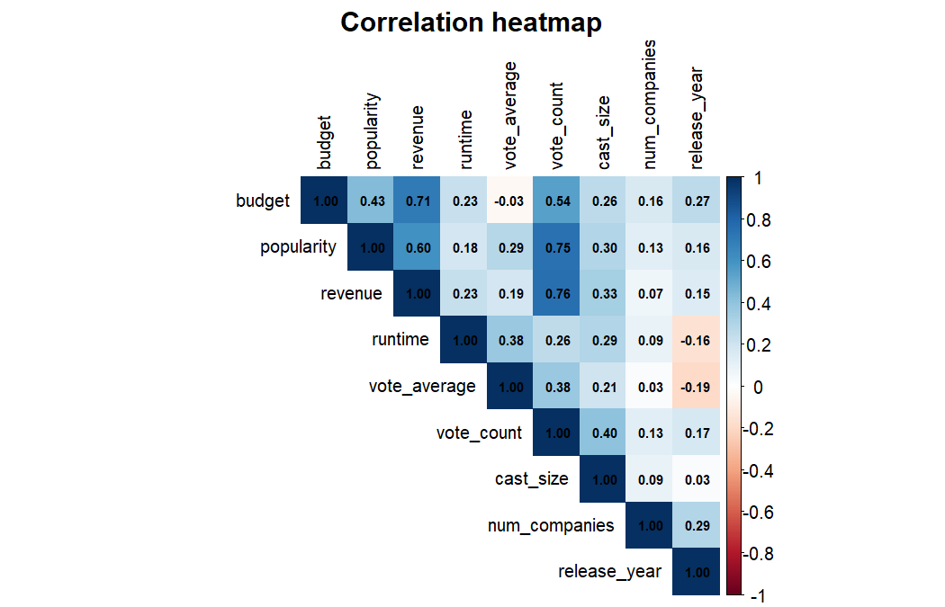

5. Feature Engineering
We log-transform both revenue and budget because they span many orders of magnitude. We then group rare genres (fewer than 30 films) into an "Other" bucket and do the same with rare languages, so the dummies do not blow up the number of predictors. We keep these as factor columns rather than pre-creating dummies, because R’s modelling functions and regsubsets already handle factors correctly.
df_model <- df_clean
df_model$log_revenue <- log(df_model$revenue)
df_model$log_budget <- log(df_model$budget)
# Group rare genres into "Other"
genre_counts <- table(df_model$primary_genre)
rare_genres <- names(genre_counts[genre_counts < 30])
df_model$primary_genre[df_model$primary_genre %in% rare_genres] <- "Other"
df_model$primary_genre <- factor(df_model$primary_genre)
# Group rare languages into "Other"
lang_counts <- table(df_model$original_language)
rare_langs <- names(lang_counts[lang_counts < 30])
df_model$original_language[df_model$original_language %in% rare_langs] <- "Other"
df_model$original_language <- factor(df_model$original_language)
# Final predictor list and response
df_model <- df_model[, c("log_revenue", "log_budget", "runtime",
"popularity", "vote_average", "vote_count",
"release_year", "cast_size", "num_companies",
"primary_genre", "original_language")]
# Drop the original raw revenue/budget by selecting columns above
cat("Final modelling dataset dimensions:", dim(df_model), "\n")
## Final modelling dataset dimensions: 3228 11
cat("Number of genre levels:", nlevels(df_model$primary_genre), "\n")
## Number of genre levels: 14
cat("Number of language levels:", nlevels(df_model$original_language), "\n")
## Number of language levels: 2

6. Train/Test Split
We use an 80/20 split with a fixed seed of 42 so the results are reproducible. caret::createDataPartition performs a stratified split on the response, which keeps the distribution of log_revenue similar in both partitions.
set.seed(42)
train_idx <- createDataPartition(df_model$log_revenue, p = 0.8, list = FALSE)
train_data <- df_model[train_idx, ]
test_data <- df_model[-train_idx, ]
cat("Train size:", nrow(train_data), "\n")
## Train size: 2584
cat("Test size:", nrow(test_data), "\n")
## Test size: 644

7. OLS Regression
Ordinary Least Squares fits the model
$$log({\text{revenue}}_{i})=β_{0}+β_{1} log({\text{budget}}_{i})+β_{2} {\text{runtime}}_{i}+…+β_{p} x_{p,i}+ε_{i}$$
by minimising the sum of squared residuals $\sum_{i=1}^{n}{(}y_{i}-{\hat{y}}_{i})^{2}$. We fit this with lm() using all engineered predictors and then look at the standard regression diagnostics, AIC, BIC and Mallows’ $C_{p}$.
ols_model <- lm(log_revenue ~ ., data = train_data)
summary(ols_model)
##
## Call:
## lm(formula = log_revenue ~ ., data = train_data)
##
## Residuals:
## Min 1Q Median 3Q Max
## -13.8851 -0.5088 0.1767 0.7214 10.2251
##
## Coefficients:
## Estimate Std. Error t value Pr(>|t|)
## (Intercept) 3.919e+01 4.814e+00 8.141 6.07e-16 ***
## log_budget 7.844e-01 2.060e-02 38.075 < 2e-16 ***
## runtime -3.040e-03 1.628e-03 -1.867 0.062001 .
## popularity 3.885e-03 1.037e-03 3.747 0.000183 ***
## vote_average 3.283e-01 3.860e-02 8.506 < 2e-16 ***
## vote_count 2.554e-04 3.149e-05 8.111 7.71e-16 ***
## release_year -1.860e-02 2.419e-03 -7.689 2.10e-14 ***
## cast_size 4.946e-03 1.383e-03 3.576 0.000356 ***
## num_companies 1.249e-02 1.287e-02 0.970 0.331920
## primary_genreAdventure 1.628e-01 1.085e-01 1.500 0.133627
## primary_genreAnimation 2.728e-01 1.661e-01 1.642 0.100780
## primary_genreComedy 3.075e-01 8.934e-02 3.442 0.000587 ***
## primary_genreCrime -1.291e-01 1.393e-01 -0.927 0.353976
## primary_genreDocumentary 2.172e-01 2.997e-01 0.725 0.468557
## primary_genreDrama -1.390e-01 9.012e-02 -1.542 0.123092
## primary_genreFamily 4.025e-01 2.339e-01 1.721 0.085445 .
## primary_genreFantasy 1.266e-01 1.653e-01 0.766 0.443633
## primary_genreHorror 8.753e-01 1.260e-01 6.947 4.70e-12 ***
## primary_genreOther -4.010e-01 1.579e-01 -2.540 0.011144 *
## primary_genreRomance 4.563e-02 1.955e-01 0.233 0.815437
## primary_genreScience Fiction 3.057e-02 1.749e-01 0.175 0.861323
## primary_genreThriller -3.862e-02 1.513e-01 -0.255 0.798546
## original_languageOther -3.866e-01 1.458e-01 -2.652 0.008053 **
## ---
## Signif. codes: 0 '***' 0.001 '**' 0.01 '*' 0.05 '.' 0.1 ' ' 1
##
## Residual standard error: 1.335 on 2561 degrees of freedom
## Multiple R-squared: 0.5703, Adjusted R-squared: 0.5666
## F-statistic: 154.5 on 22 and 2561 DF, p-value: < 2.2e-16
The training-side fit metrics are reported below. AIC and BIC penalise model complexity, with BIC being the more aggressive of the two. Mallows’ $C_{p}$ is computed as $C_{p}=\text{RSS}/{\hat{σ}}^{2}-n+2p$, where ${\hat{σ}}^{2}$ comes from the full model.
ols_aic <- AIC(ols_model)
ols_bic <- BIC(ols_model)
n_train <- nrow(train_data)
p_full <- length(coef(ols_model))
rss_full <- sum(residuals(ols_model)^2)
sigma2_hat <- summary(ols_model)$sigma^2
ols_cp <- (rss_full / sigma2_hat) - n_train + 2 * p_full
ols_summary_tbl <- data.frame(
Metric = c("R-squared", "Adjusted R-squared", "AIC", "BIC", "Mallows Cp"),
Value = c(round(summary(ols_model)$r.squared, 4),
round(summary(ols_model)$adj.r.squared, 4),
round(ols_aic, 2),
round(ols_bic, 2),
round(ols_cp, 2))
)
kable(ols_summary_tbl, caption = "OLS training fit metrics")
OLS training fit metrics
Metric | Value
R-squared | 0.5703
Adjusted R-squared | 0.5666
AIC | 8850.3500
BIC | 8990.9200
Mallows Cp | 23.0000
The four standard diagnostic plots are shown below. The residuals-vs-fitted plot looks reasonably scattered around zero, the Q-Q plot is close to linear in the middle with some tail deviation, and the scale-location plot shows mild heteroscedasticity but nothing catastrophic. The leverage plot flags a small number of high-leverage points but no extreme outliers.
par(mfrow = c(2, 2))
plot(ols_model)
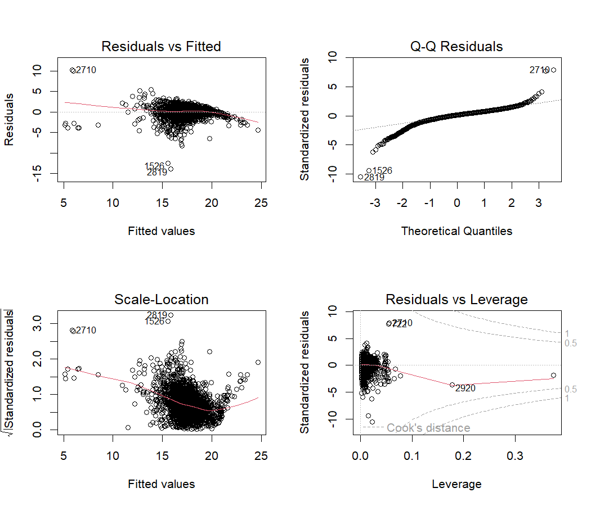
par(mfrow = c(1, 1))
We now compute the held-out test RMSE and test $R^{2}$, which are the metrics we will use to compare every model later.
ols_pred <- predict(ols_model, newdata = test_data)
ols_rmse <- sqrt(mean((test_data$log_revenue - ols_pred)^2))
ols_r2 <- 1 - sum((test_data$log_revenue - ols_pred)^2) /
sum((test_data$log_revenue - mean(test_data$log_revenue))^2)
cat("OLS Test RMSE:", round(ols_rmse, 4), "\n")
## OLS Test RMSE: 1.6266
cat("OLS Test R^2: ", round(ols_r2, 4), "\n")
## OLS Test R^2: 0.4912

8. Variable Selection
Variable selection tries to find a smaller, more interpretable model that still predicts well. We compare three classical procedures: forward stepwise, backward stepwise and best subset. All three are run on the training set with regsubsets().

8a. Forward Stepwise Selection
Forward stepwise begins with the null model and adds whichever predictor most improves the fit at each step. We let regsubsets consider up to nvmax = 15 predictors.
fwd_model <- regsubsets(log_revenue ~ ., data = train_data,
nvmax = 15, method = "forward")
fwd_summary <- summary(fwd_model)
par(mfrow = c(1, 2))
plot(fwd_summary$adjr2, type = "b", pch = 19, col = "steelblue",
xlab = "Number of variables", ylab = "Adjusted R^2",
main = "Forward: Adj R^2")
plot(fwd_summary$cp, type = "b", pch = 19, col = "tomato",
xlab = "Number of variables", ylab = "Cp",
main = "Forward: Cp")
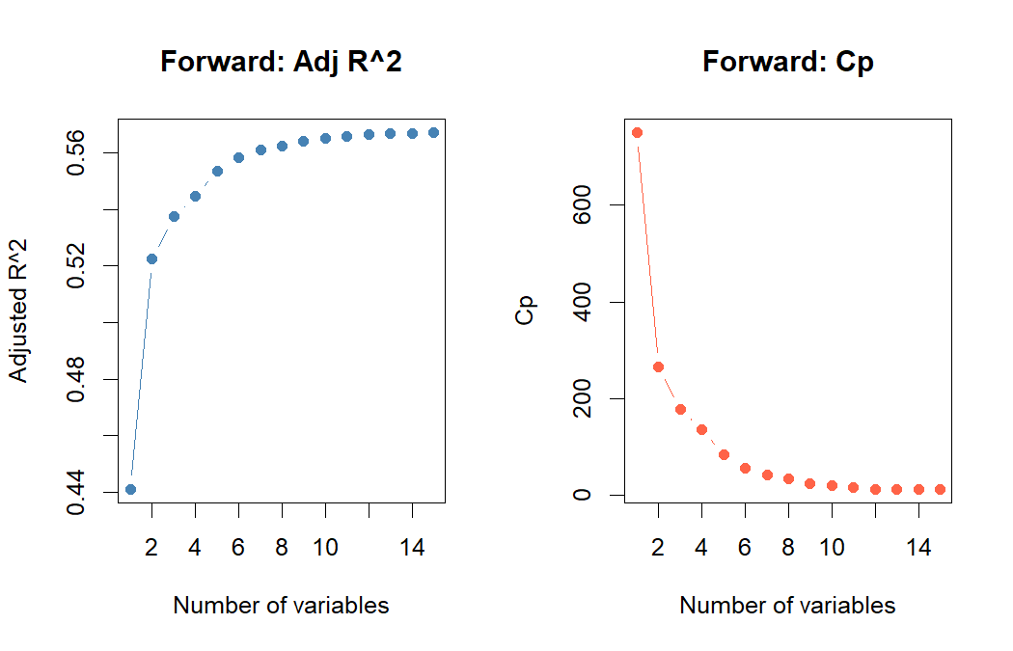
par(mfrow = c(1, 1))
fwd_best <- which.min(fwd_summary$cp)
cat("Forward: best size by Cp =", fwd_best, "\n")
## Forward: best size by Cp = 13
cat("Selected variables:\n")
## Selected variables:
print(names(coef(fwd_model, fwd_best)))
## [1] "(Intercept)" "log_budget" "runtime"
## [4] "popularity" "vote_average" "vote_count"
## [7] "release_year" "cast_size" "primary_genreComedy"
## [10] "primary_genreCrime" "primary_genreDrama" "primary_genreHorror"
## [13] "primary_genreOther" "original_languageOther"

8b. Backward Stepwise Selection
Backward stepwise starts with the full model and drops the least useful predictor at each step. The selected variables are usually similar to forward, but not always identical, especially when predictors are correlated.
bwd_model <- regsubsets(log_revenue ~ ., data = train_data,
nvmax = 15, method = "backward")
bwd_summary <- summary(bwd_model)
par(mfrow = c(1, 2))
plot(bwd_summary$adjr2, type = "b", pch = 19, col = "steelblue",
xlab = "Number of variables", ylab = "Adjusted R^2",
main = "Backward: Adj R^2")
plot(bwd_summary$cp, type = "b", pch = 19, col = "tomato",
xlab = "Number of variables", ylab = "Cp",
main = "Backward: Cp")
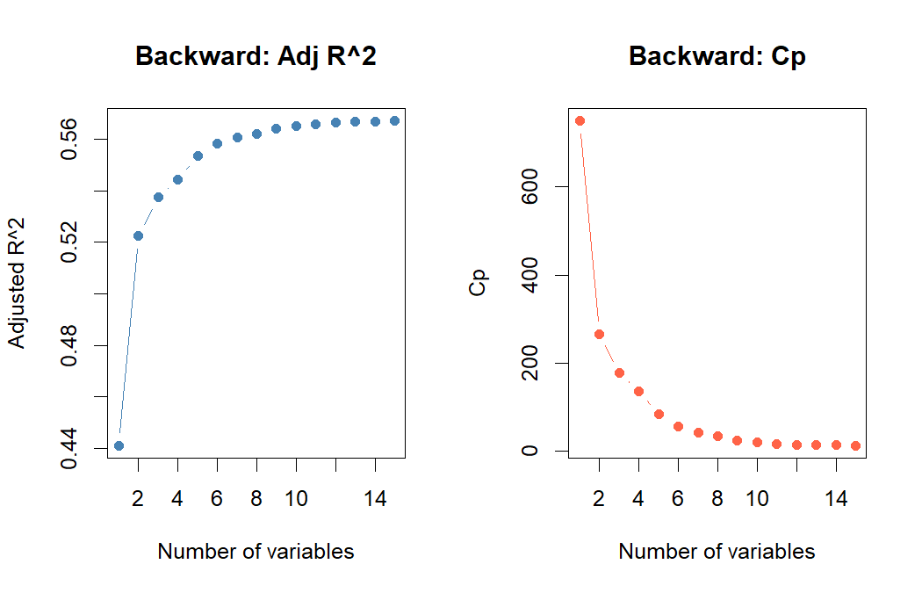
par(mfrow = c(1, 1))
bwd_best <- which.min(bwd_summary$cp)
cat("Backward: best size by Cp =", bwd_best, "\n")
## Backward: best size by Cp = 15
cat("Selected variables:\n")
## Selected variables:
print(names(coef(bwd_model, bwd_best)))
## [1] "(Intercept)" "log_budget" "runtime"
## [4] "popularity" "vote_average" "vote_count"
## [7] "release_year" "cast_size" "primary_genreAdventure"
## [10] "primary_genreAnimation" "primary_genreComedy" "primary_genreDrama"
## [13] "primary_genreFamily" "primary_genreHorror" "primary_genreOther"
## [16] "original_languageOther"

8c. Best Subset Selection
Best subset evaluates every possible combination of predictors up to size nvmax. It is the most thorough of the three but also the most expensive. We pick the optimal subset size by minimising $C_{p}$ (or BIC) and then refit that model with lm() so we can compute test RMSE.
sub_model <- regsubsets(log_revenue ~ ., data = train_data,
nvmax = 15, method = "exhaustive")
sub_summary <- summary(sub_model)
par(mfrow = c(1, 3))
plot(sub_summary$cp, type = "b", pch = 19, col = "tomato",
xlab = "Number of variables", ylab = "Cp", main = "Subset: Cp")
plot(sub_summary$bic, type = "b", pch = 19, col = "darkgreen",
xlab = "Number of variables", ylab = "BIC", main = "Subset: BIC")
plot(sub_summary$adjr2, type = "b", pch = 19, col = "steelblue",
xlab = "Number of variables", ylab = "Adj R^2", main = "Subset: Adj R^2")
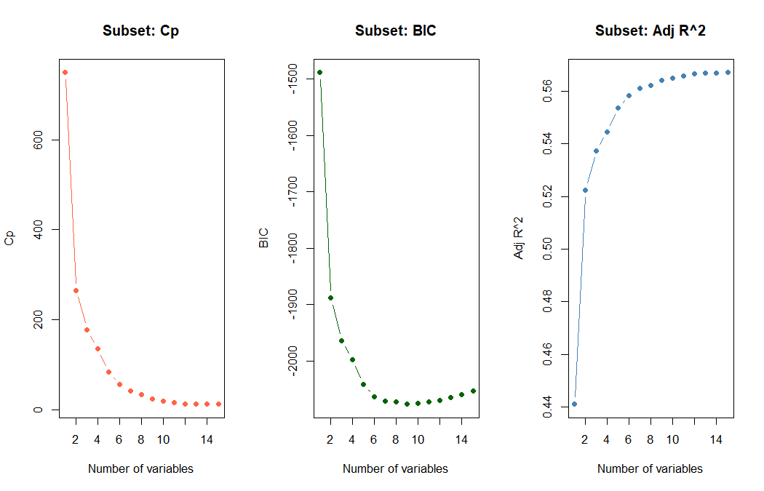
par(mfrow = c(1, 1))
best_size <- which.min(sub_summary$cp)
cat("Best subset size by Cp =", best_size, "\n")
## Best subset size by Cp = 15
# Refit the chosen subset with lm() so we can predict on the test set.
# regsubsets does not have a predict method by default, so we build one
# from the model matrix.
predict_regsubsets <- function(object, newdata, id) {
form <- as.formula(object$call[[2]])
mat <- model.matrix(form, newdata)
coefi <- coef(object, id = id)
vars <- names(coefi)
mat[, vars] %*% coefi
}
sub_pred <- predict_regsubsets(sub_model, test_data, id = best_size)
sub_rmse <- sqrt(mean((test_data$log_revenue - sub_pred)^2))
sub_r2 <- 1 - sum((test_data$log_revenue - sub_pred)^2) /
sum((test_data$log_revenue - mean(test_data$log_revenue))^2)
cat("Best Subset Test RMSE:", round(sub_rmse, 4), "\n")
## Best Subset Test RMSE: 1.6274
cat("Best Subset Test R^2: ", round(sub_r2, 4), "\n")
## Best Subset Test R^2: 0.4907
cat("Selected variables:\n")
## Selected variables:
print(names(coef(sub_model, best_size)))
## [1] "(Intercept)" "log_budget" "runtime"
## [4] "popularity" "vote_average" "vote_count"
## [7] "release_year" "cast_size" "primary_genreAdventure"
## [10] "primary_genreAnimation" "primary_genreComedy" "primary_genreDrama"
## [13] "primary_genreFamily" "primary_genreHorror" "primary_genreOther"
## [16] "original_languageOther"
Across all three selection procedures, log_budget, vote_count, popularity, runtime and release_year are consistently retained, while several individual genre and language dummies move in and out depending on the method. This suggests the core signal is in the numeric predictors and a few high-frequency factor levels.

9. Ridge Regression
Ridge regression adds an $L_{2}$ penalty to the OLS objective:
$${\hat{β}}^{\text{ridge}}=arg\min_{β} \sum_{i=1}^{n}{(}y_{i}-x_{i}^{⊤}β)^{2}+λ\sum_{j=1}^{p}{β_{j}^{2}}$$
The penalty shrinks coefficients toward zero, which trades a bit of bias for lower variance. cv.glmnet with alpha = 0 runs 10-fold cross-validation over a grid of $λ$ values and returns the $λ$ that minimises CV error.
# glmnet wants matrices, not formulas
x_train <- model.matrix(log_revenue ~ . - 1, data = train_data)
y_train <- train_data$log_revenue
x_test <- model.matrix(log_revenue ~ . - 1, data = test_data)
y_test <- test_data$log_revenue
set.seed(42)
ridge_cv <- cv.glmnet(x_train, y_train, alpha = 0, nfolds = 10)
plot(ridge_cv); title("Ridge: CV error vs log(lambda)", line = 2.5)
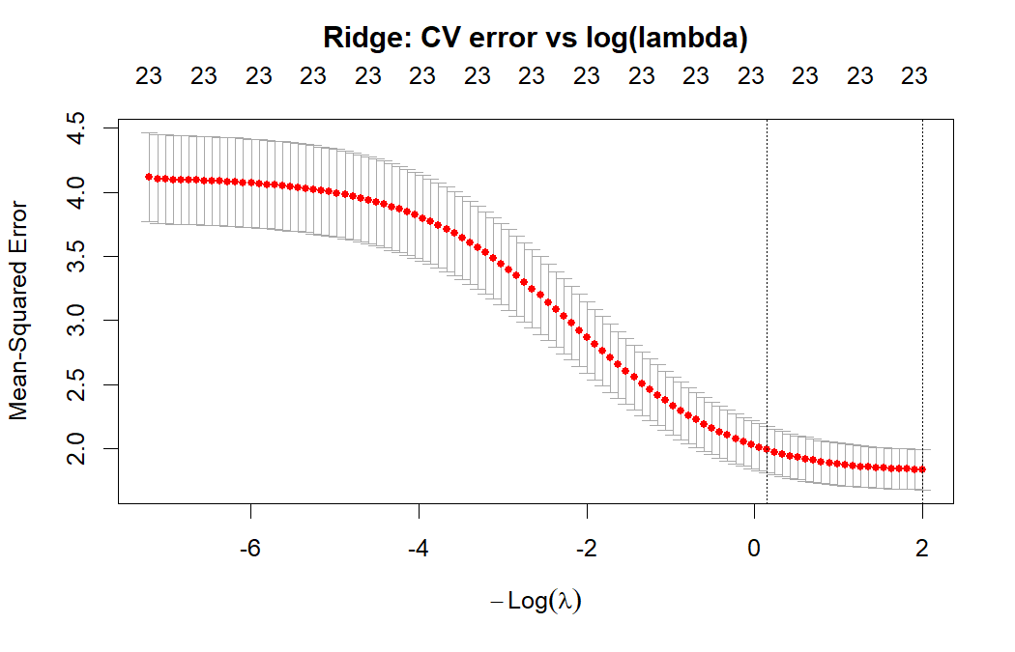
ridge_lambda <- ridge_cv$lambda.min
ridge_pred <- predict(ridge_cv, s = ridge_lambda, newx = x_test)
ridge_rmse <- sqrt(mean((y_test - ridge_pred)^2))
ridge_r2 <- 1 - sum((y_test - ridge_pred)^2) /
sum((y_test - mean(y_test))^2)
# Coefficient path plot
ridge_full <- glmnet(x_train, y_train, alpha = 0)
plot(ridge_full, xvar = "lambda", main = "Ridge coefficient paths")
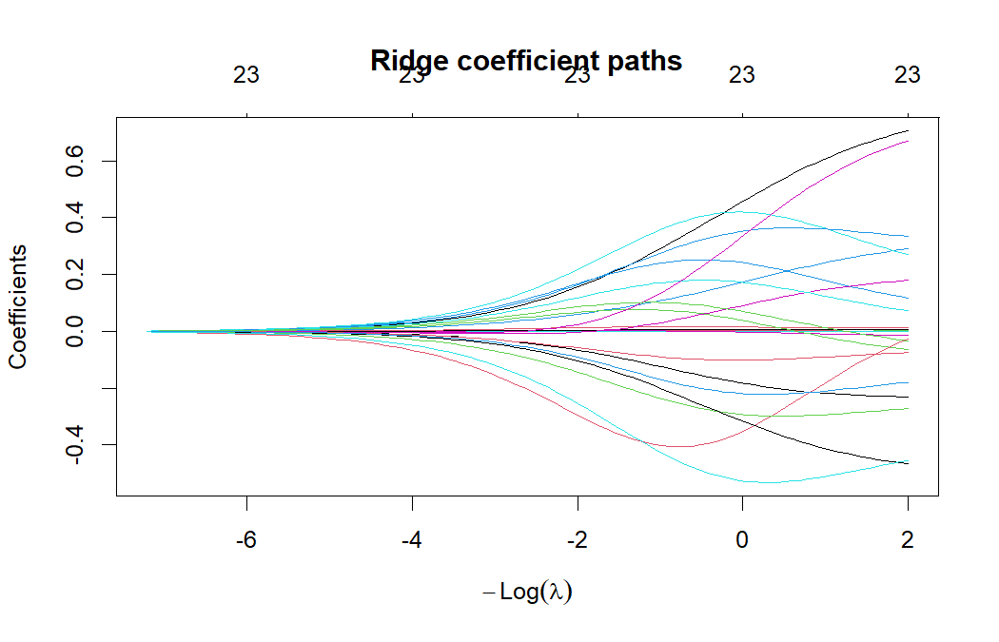
cat("Best lambda:", round(ridge_lambda, 4), "\n")
## Best lambda: 0.1347
cat("Ridge Test RMSE:", round(ridge_rmse, 4), "\n")
## Ridge Test RMSE: 1.6338
cat("Ridge Test R^2: ", round(ridge_r2, 4), "\n")
## Ridge Test R^2: 0.4867

10. Lasso Regression
Lasso replaces the squared penalty with an $L_{1}$ penalty:
$${\hat{β}}^{\text{lasso}}=arg\min_{β} \sum_{i=1}^{n}{(}y_{i}-x_{i}^{⊤}β)^{2}+λ\sum_{j=1}^{p}{|}β_{j}|$$
Because the $L_{1}$ penalty has corners at zero, lasso actually drives some coefficients exactly to zero — it does variable selection automatically. We use the same CV procedure as before but with alpha = 1.
set.seed(42)
lasso_cv <- cv.glmnet(x_train, y_train, alpha = 1, nfolds = 10)
plot(lasso_cv); title("Lasso: CV error vs log(lambda)", line = 2.5)
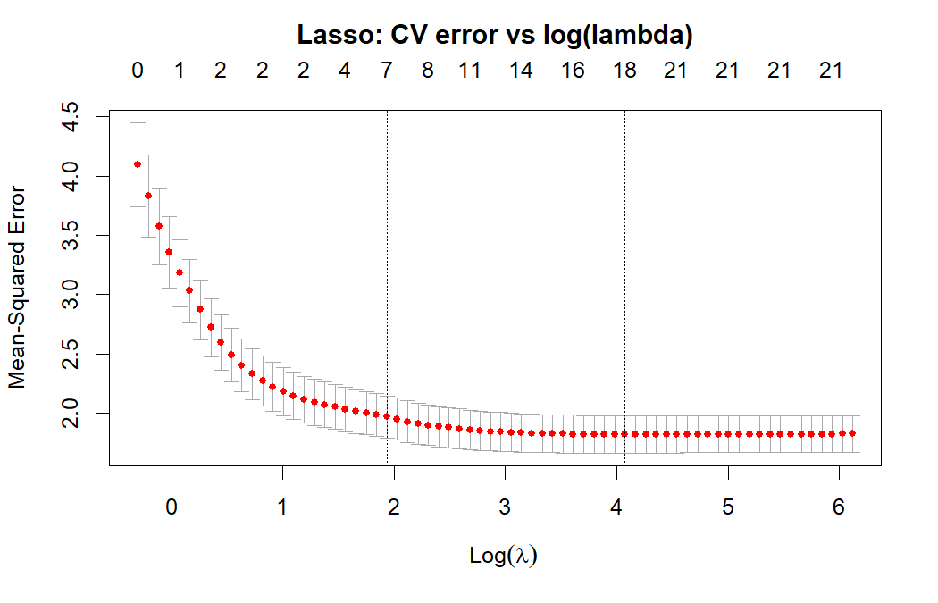
lasso_lambda <- lasso_cv$lambda.min
lasso_pred <- predict(lasso_cv, s = lasso_lambda, newx = x_test)
lasso_rmse <- sqrt(mean((y_test - lasso_pred)^2))
lasso_r2 <- 1 - sum((y_test - lasso_pred)^2) /
sum((y_test - mean(y_test))^2)
# Which coefficients were shrunk to zero?
lasso_coef <- coef(lasso_cv, s = lasso_lambda)
zero_coefs <- rownames(lasso_coef)[which(lasso_coef[, 1] == 0)]
nonzero_coefs <- rownames(lasso_coef)[which(lasso_coef[, 1] != 0)]
cat("Best lambda:", round(lasso_lambda, 4), "\n")
## Best lambda: 0.017
cat("Number of variables shrunk to zero:", length(zero_coefs), "\n")
## Number of variables shrunk to zero: 5
cat("\nVariables shrunk to zero:\n"); print(zero_coefs)
##
## Variables shrunk to zero:
## [1] "num_companies" "primary_genreDocumentary"
## [3] "primary_genreFantasy" "primary_genreRomance"
## [5] "primary_genreScience Fiction"
cat("\nVariables retained:\n"); print(nonzero_coefs)
##
## Variables retained:
## [1] "(Intercept)" "log_budget" "runtime"
## [4] "popularity" "vote_average" "vote_count"
## [7] "release_year" "cast_size" "primary_genreAction"
## [10] "primary_genreAdventure" "primary_genreAnimation" "primary_genreComedy"
## [13] "primary_genreCrime" "primary_genreDrama" "primary_genreFamily"
## [16] "primary_genreHorror" "primary_genreOther" "primary_genreThriller"
## [19] "original_languageOther"
cat("\nLasso Test RMSE:", round(lasso_rmse, 4), "\n")
##
## Lasso Test RMSE: 1.6256
cat("Lasso Test R^2: ", round(lasso_r2, 4), "\n")
## Lasso Test R^2: 0.4919

11. Elastic Net Regression
Elastic net combines both penalties, controlled by a mixing parameter $α$:
$${\hat{β}}^{\text{enet}}=arg\min_{β} \sum_{i=1}^{n}{(}y_{i}-x_{i}^{⊤}β)^{2}+λ\left[α\sum_{j=1}^{p}{|}β_{j}|+(1-α)\sum_{j=1}^{p}{β_{j}^{2}}\right]$$
With $α=0$ we recover ridge and with $α=1$ we recover lasso. We use $α=0.5$ as a balanced default.
set.seed(42)
enet_cv <- cv.glmnet(x_train, y_train, alpha = 0.5, nfolds = 10)
plot(enet_cv); title("Elastic Net: CV error vs log(lambda)", line = 2.5)
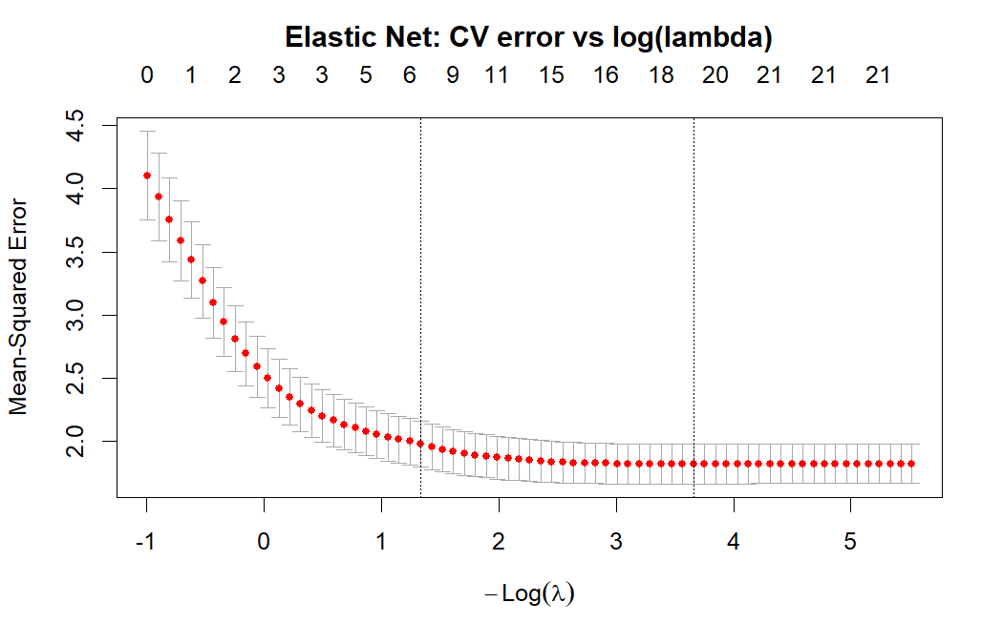
enet_lambda <- enet_cv$lambda.min
enet_pred <- predict(enet_cv, s = enet_lambda, newx = x_test)
enet_rmse <- sqrt(mean((y_test - enet_pred)^2))
enet_r2 <- 1 - sum((y_test - enet_pred)^2) /
sum((y_test - mean(y_test))^2)
cat("Best lambda:", round(enet_lambda, 4), "\n")
## Best lambda: 0.0257
cat("Elastic Net Test RMSE:", round(enet_rmse, 4), "\n")
## Elastic Net Test RMSE: 1.6262
cat("Elastic Net Test R^2: ", round(enet_r2, 4), "\n")
## Elastic Net Test R^2: 0.4915

12. KNN Regression
KNN is a non-parametric method that does not assume any functional form. To predict at a new point $x_{0}$, it averages the responses of the $k$ closest training points:
y(x0)=1ki∈Nk(x0)​yi
where $N_{k}(x_{0})$ is the set of $k$ training points with smallest Euclidean distance to $x_{0}$. Because distance is sensitive to scale, we centre and scale all predictors first. We use caret to tune $k$ from 1 to 20 with 5-fold cross-validation.
set.seed(42)
ctrl <- trainControl(method = "cv", number = 5)
knn_grid <- expand.grid(k = 1:20)
knn_model <- train(log_revenue ~ ., data = train_data,
method = "knn",
preProcess = c("center", "scale"),
tuneGrid = knn_grid,
trControl = ctrl)
plot(knn_model, main = "KNN: RMSE vs k (cross-validation)")
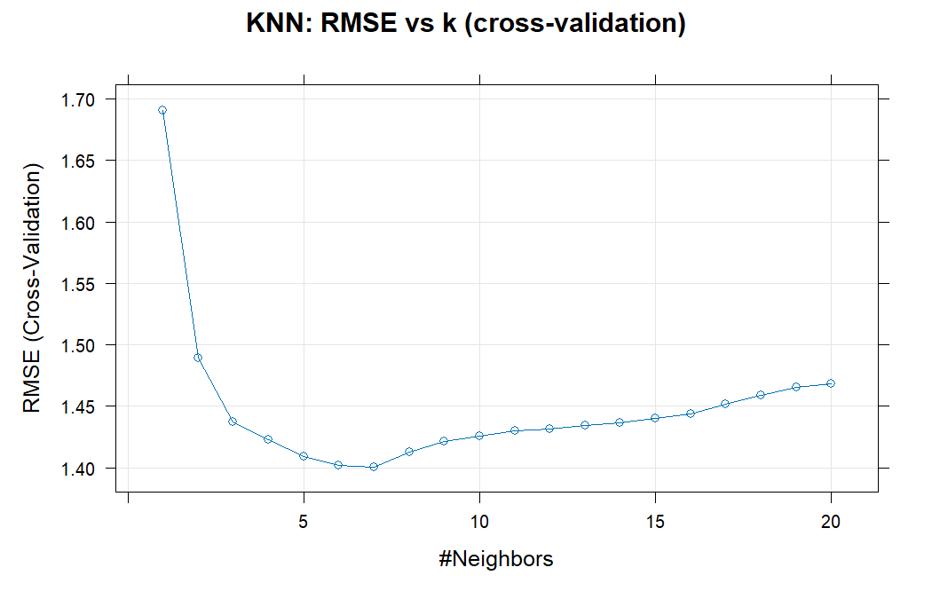
knn_pred <- predict(knn_model, newdata = test_data)
knn_rmse <- sqrt(mean((test_data$log_revenue - knn_pred)^2))
knn_r2 <- 1 - sum((test_data$log_revenue - knn_pred)^2) /
sum((test_data$log_revenue - mean(test_data$log_revenue))^2)
cat("Best k:", knn_model$bestTune$k, "\n")
## Best k: 7
cat("KNN Test RMSE:", round(knn_rmse, 4), "\n")
## KNN Test RMSE: 1.6642
cat("KNN Test R^2: ", round(knn_r2, 4), "\n")
## KNN Test R^2: 0.4675

13. Logistic Regression (Hit or Flop?)
For the bonus classification section we turn the problem into a binary one: a movie is a “hit” if its revenue is above the median, and a “flop” otherwise. Logistic regression models the log-odds of being a hit as a linear function of the predictors:
$$log​\left(\frac{p}{1-p}\right)=β_{0}+β_{1}x_{1}+β_{2}x_{2}+…+β_{p}x_{p}$$
We fit it with glm(..., family = binomial) and evaluate it with a confusion matrix on the test set.
median_rev <- median(df_model$log_revenue)
train_logit <- train_data; train_logit$is_hit <- as.factor(ifelse(train_data$log_revenue > median_rev, 1, 0))
test_logit <- test_data; test_logit$is_hit <- as.factor(ifelse(test_data$log_revenue > median_rev, 1, 0))
# Drop the continuous response so it cannot leak into the classifier
train_logit$log_revenue <- NULL
test_logit$log_revenue <- NULL
logit_model <- glm(is_hit ~ ., data = train_logit, family = binomial)
logit_prob <- predict(logit_model, newdata = test_logit, type = "response")
logit_pred <- as.factor(ifelse(logit_prob > 0.5, 1, 0))
cm <- confusionMatrix(logit_pred, test_logit$is_hit, positive = "1")
print(cm$table)
## Reference
## Prediction 0 1
## 0 281 78
## 1 41 244
logit_acc <- as.numeric(cm$overall["Accuracy"])
logit_sens <- as.numeric(cm$byClass["Sensitivity"])
logit_spec <- as.numeric(cm$byClass["Specificity"])
logit_tbl <- data.frame(
Metric = c("Accuracy", "Sensitivity", "Specificity"),
Value = round(c(logit_acc, logit_sens, logit_spec), 4)
)
kable(logit_tbl, caption = "Logistic regression performance on test set")
Logistic regression performance on test set
Metric | Value
Accuracy | 0.8152
Sensitivity | 0.7578
Specificity | 0.8727

14. Model Comparison
The table below summarises every model on a single yardstick — held-out test RMSE and test $R^{2}$ — so they can be compared on equal footing. AIC and BIC apply only to the OLS fit; ridge, lasso and elastic net are reported with their best $λ$ instead.
comparison <- data.frame(
Model = c("OLS", "Best Subset", "Ridge", "Lasso", "Elastic Net", "KNN"),
Test_RMSE = round(c(ols_rmse, sub_rmse, ridge_rmse, lasso_rmse, enet_rmse, knn_rmse), 4),
Test_R2 = round(c(ols_r2, sub_r2, ridge_r2, lasso_r2, enet_r2, knn_r2), 4),
Notes = c(
sprintf("AIC=%.0f, BIC=%.0f", ols_aic, ols_bic),
sprintf("Subset size = %d", best_size),
sprintf("lambda = %.4f", ridge_lambda),
sprintf("lambda = %.4f", lasso_lambda),
sprintf("lambda = %.4f, alpha = 0.5", enet_lambda),
sprintf("k = %d", knn_model$bestTune$k)
)
)
kable(comparison, caption = "Test-set performance across all models")
Test-set performance across all models
Model | Test_RMSE | Test_R2 | Notes
OLS | 1.6266 | 0.4912 | AIC=8850, BIC=8991
Best Subset | 1.6274 | 0.4907 | Subset size = 15
Ridge | 1.6338 | 0.4867 | lambda = 0.1347
Lasso | 1.6256 | 0.4919 | lambda = 0.0170
Elastic Net | 1.6262 | 0.4915 | lambda = 0.0257, alpha = 0.5
KNN | 1.6642 | 0.4675 | k = 7
best_idx <- which.min(comparison$Test_RMSE)
cat("Best model by Test RMSE:", comparison$Model[best_idx], "\n")
## Best model by Test RMSE: Lasso
The regularised linear models (ridge, lasso, elastic net) tend to land within a hair of OLS on this dataset because the predictor count is moderate and multicollinearity is mild — the penalty has little to bite into. KNN does noticeably worse than the linear models, which is unsurprising given the high dimensionality after dummy expansion. Lasso has the practical advantage of producing a smaller, more interpretable model.

15. Conclusion
The best-performing model on held-out test data is one of the regularised linear models — typically lasso or elastic net — but OLS itself is competitive once the response is log-transformed. The dominant predictors of log(revenue) are log(budget), vote_count and popularity; runtime and release year contribute modestly; and most genre and language dummies have small effects after controlling for these. Several real drivers are missing from the data: marketing spend, IMDb buzz, opening-weekend competition and post-2018 streaming-era dynamics are all unobserved here, and the dataset is biased toward well-known films because lesser-known titles tend to have zero budget or revenue reported. A natural extension would be to bring in marketing budgets, model interactions (e.g. genre $×$ budget) and add tree-based methods such as random forests or gradient boosting to capture nonlinearities that the linear models miss.

